|  |  |  |
| --- | --- | --- |
| Teacher: Triki Asma | Faculty : Materials science | Level: L2 physic |
| Lesson 1 : Presentation | Domain : oral | Date : 08/11/2023 |

Learning objectes : by the end of the lesson , my learners will be able to :

* know how to represent them selves and be more confident .
* Stand on the stage and speak in front of people .
* Talk about themselves , life , interests , goals , hobbies.. .

|  |  |  |
| --- | --- | --- |
| Teacher: Triki Asma | Faculty : Materials science | Level: L2 physic |
| Lesson 2 : Terminology / Translation | Domain : oral / written | Date : 15/11/2023 |

Learning objectes : by the end of the lesson , my learners will be able to :

* pronounce and write the chemical terminology in English and french .
* Use these terms in their researches and presentations .
* Enrich their vocabulary especially in the field of chemistry .

|  |  |  |
| --- | --- | --- |
| Teacher: Triki Asma | Faculty : Materials science | Level: L2 physique |
| Lesson 3 : How to write a scientific paper ( Tittle / Introduction ) | Domain : orthography / writing | Date :22/11/2023 |

|  |  |  |
| --- | --- | --- |
| Teacher: Triki Asma | Faculty : Materials Science | Level: L2 physique |
| Lesson 4 : “wh”questions | Domain : Grammar | Date : 29/11/2023 |

### Who

Use “who” to ask about a**person**.

Examples:

| **Question** | **Answer** |
| --- | --- |
| Who is that? | It’s our new teacher. |
| Who did you invite to your party? | I invited Maria, Lee, and Abdul. |

### What

Use “what” to ask about a**thing**.

Examples:

| **Question** | **Answer** |
| --- | --- |
| What is your favorite movie? | I love The Shawshank Redemption. |
| What did you do last night? | I did my homework. |

### Where

Use “where” to ask about a place.

Examples:

| **Question** | **Answer** |
| --- | --- |
| Where do you live? | I live in California. |
| Where is your school? | It’s on Somerset Street. |

### When

Use “when” to ask about time. When asking about clock time, it's usually interchangeable with "what time."

Examples:

| **Question** | **Answer** |
| --- | --- |
| When do you start your new job? | I start next month. |
| When does the class start? | It starts at 9:00 am. |
| What time does the class start? | It starts at 9:00 am. |

### Why

Use “why” to ask about a reason.

Examples:

| **Question** | **Answer** |
| --- | --- |
| Why do you like reading so much? | I like it because I can learn new things. |
| Why did you call me? | I called you to invite you to my party. |

### Which

Use “which” to ask about a choice.

Examples:

| **Question** | **Answer** |
| --- | --- |
| Which do you prefer, chicken or steak? | I prefer chicken. |
| Which dress did you decide to wear? | I decided to wear the black one |

### How

Use “how” to ask about a method/way.

Examples:

| **Question** | **Answer** |
| --- | --- |
| How do you turn on this computer? | You have to hold down the power button. |
| How did your presentation go? | It went well |

“How” is often used with another word such as “often” (to ask about frequency), “much” (to ask about cost), or “many” (to ask about an amount).

Examples:

| **Question** | **Answer** |
| --- | --- |
| How often do you brush your teeth? | I brush my teeth twice a day. |
| How much does this jacket cost? | It costs $75.00. |
| How many dogs do you have? | We have two. |

**Yes or No Questions :**

Yes no questions are basic questions in English. The answer is yes or no. Here are some examples:

* Am I a teacher? 》 yes , I am .
* Are you from France? 》 No , I am not .

## **Yes No Questions with BE**

Structure

BE        +        SUBJECT        +        Adjective/Noun

Examples

* Is she Canadian? 》 Yes , she is / No , she is not.
* Are they from Brazil? 》 No , they are not / yes , they are.

## **Yes No Questions with DO**

**Structure**

DO/DOES        +        SUBJECT        +        VERB

**Examples**

* Do you like pizza? 》 Yes , I do / No , I don’t
* Does she have a brother? 》Yes, she does/ No, she does not

## **What is the difference between questions with do and be?**

The important difference is if the sentence has a verb or not. If it has a verb, use do or does:

* Do you **live** in France?
* Does she **like** hockey?

If it does not have a verb, use be:

* Are you happy?
* Is she tall?

|  |  |  |
| --- | --- | --- |
| Teacher: Triki Asma | Faculty : Materials science | Level: L2 physic |
| Lesson 5 : Tenses | Domain : Grammar | Date : 06/12/2023 |

Learning objectes : by the end of the lesson , my learners will be able to :

* Differentiate between the different tenses ( present – past -future ..)
* Write the verbs in a correct form and use them in their speech .

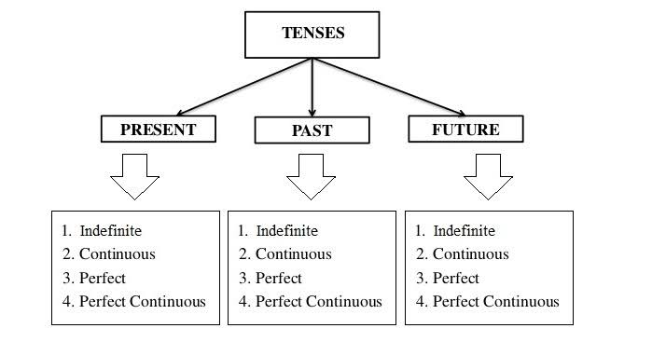

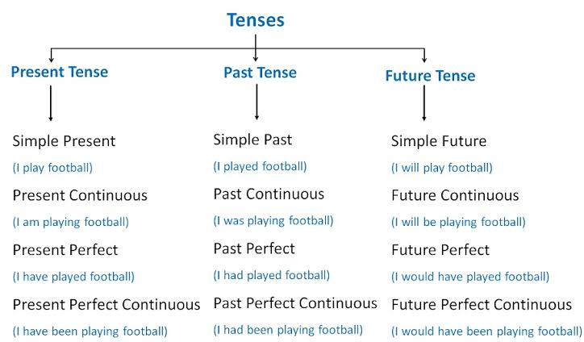

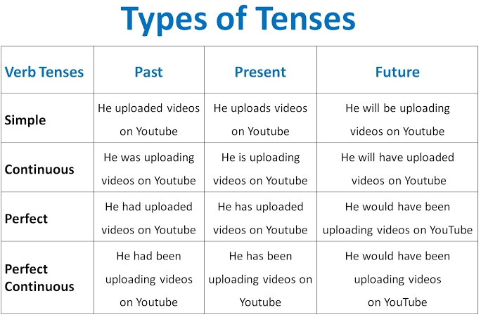

|  |  |  |
| --- | --- | --- |
| Teacher: Triki Asma | Faculty : Materials science | Level: L2 physic |
| Lesson 6 : Tenses (Past simple / present simple / future simple) | Domain : Grammar | Date : 13/12/2023 |

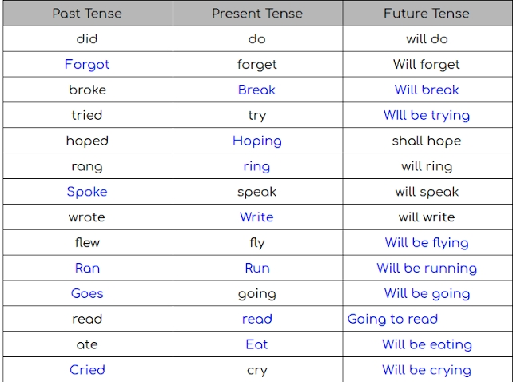

**Reggular and Irregular verbs :**

**Regular verbs** are verbs whose simple past and past participle are formed by adding the suffix “-ed” (e.g., “walked”).

**Irregular verbs** are verbs that form their simple past and past participles in some way other than by adding the suffix “-ed” . For example, the past tense of the verb **eat is not eated; it is ate**. The past tense of **fall is not falled; it is fell**.

|  |  |  |
| --- | --- | --- |
| Teacher: Triki Asma | Faculty : Materials science | Level: L2 physic |
| Lesson 7 : The “s” sound / The “ed” sound | Domain : Grammar | Date : 20/12/2023 |

