BUSINESS MANAGEMENT AND ORGANIZATION

# Table of Contents

Chapter 1. Theoretical Background 4

1. Background 4
   1. Understanding the business organisation – a multidisciplinary approach 5
   2. Decision making 6
   3. The management role 6
2. Universality of management: 9
   1. The Reality of Work 9

Chapter 2. Management and Business Organization 11

1. Integrative Managerial Issues 11
   1. Managing in a Global Environment 11
      1. The economic environment 11
      2. The political/legal environment 12
      3. The cultural environment 12
      4. Global Management in Today’s World 12
   2. Managing Diversity 13
      1. Diversity 13
      2. Types of Workplace Diversity 13
      3. Challenges in Managing Diversity 14
      4. Workplace Diversity Initiatives 15
   3. Managing Social Responsibility and Ethics 15
      1. Social Responsibility 15
      2. Managers and Ethical Behavior 16
      3. Social Responsibility and Ethics Issues In Today’s World 16
   4. Managing Change and Innovation 17
      1. Types of Organizational Change 17
      2. Contemporary Issues in Managing Change 17
      3. Stimulating Innovation 17
2. Planning 18
   1. Foundations of Planning 19
      1. Goals and Plans 19
      2. Setting Goals and Developing Plans 20
      3. Contemporary Issues in Planning 20
   2. Strategic Management 21
      1. The strategic management process 21
      2. Corporate Strategies 21
      3. Competitive Strategies 22
      4. Current Strategic Management Issues 22
3. Organizing 23
   1. Basic Organizational Design 23
      1. Designing Organizational Structure 23
      2. Traditional Organizational Design 24
   2. Adaptive Organizational Design 24
   3. Managing Human Resources 24
      1. Managing Teams 25
4. Leading 26
   1. Understanding Individual Behavior 26
      1. Attitudes and Job Performance 27
      2. Personality 28
      3. Perception 29
      4. Learning 30
   2. Social Learning 30
   3. Managers and Communication 32
      1. Methods of Interpersonal Communication 32
      2. Effective Interpersonal Communication 33
      3. Organizational Communication 33
      4. Organizational Communication Networks 34
   4. Motivating Employees 35
      1. Early Theories of Motivation 35
      2. Contemporary Theories of Motivation 36
   5. Managers as Leaders 38
      1. Early theories of leadership 38
      2. The three major contingency theories of leadership 39
5. Controlling 40
   1. The Control Process 41
   2. Controlling for Organizational Performance 42
   3. Tools for measuring Organizational Performance 42
   4. Managing Operations 43
      1. The Role of Operations Management 43
6. Planning Techniques 44
   1. Techniques for Assessing the Environment 44
      1. Environmental Scanning 44
      2. Forecasting 45
      3. Benchmarking 46
   2. Techniques for Allocating Resources 47
      1. Budgeting 47
      2. Scheduling 48

**CHAPTER 1. THEORETICAL BACKGROUND**

The first chapter will serve two purposes: The first is to equip you with the understanding you will need of the main key terms you are going to be working with. However, you are not just given definitions. The idea is to offer you a way of developing your own understanding of key concepts and to be able to evaluate the meanings others attach to the terms you will meet. Secondly, Section 1 discusses the background to the subject so that you can appreciate why and how it has developed. The different influences on its development are important. At first it may be difficult to see how this is relevant to your wanting to understand business and management today, but the developments of today emerge from this background and are often influenced by the major events and theories of the past.

This study adopts a gender perspective to analyze funding decisions made by an investment fund that invests equity stakes in new ventures. Prior research has indicated that there is gender skewness in risk capital investments resulting from a combination of demand- and supply-side issues. We apply signaling theory to examine the interface between demand and supply to understand gender biases related to risk capital investments. In-depth analyses of decision documents from four investment cases show that gender plays a role in the signals that are communicated in the prefunding entrepreneur investor relationship.

# Background

Let’s think about the concept of ‘organisation’. Many definitions are possible, but most of these include the characteristics of people, goals and structures. People are social beings and, by and large, tend to cooperate in interdependent relationships to achieve common aims. Originally people formed simple family and tribal structures. Today we have evolved into a complex society characterised by large, formal and increasingly global structures. For our purposes, then, we can define an organisation as: a social entity that provides the necessary structures to achieve specific aims.

For our purposes in this subject guide, we will understand the term business to mean: a commercial enterprise or establishment that trades in goods or services.

We can define the business organisation as: an entity that is both commercial and social, which provides the necessary structures to achieve the central objective of trades in goods or services.

# Understanding the business organisation – a multidisciplinary approach

We are going to focus, in this section, on sociology, psychology, anthropology (the behavioral sciences) and economics, as they will provide the major theoretical foundations for other sections in the guide.

Sociological perspectives: The main ways in which sociology informs us about business and management are to help explain:

* How people interact at work
* The effects of different organisational structures on people; sociology can particularly contribute to our understanding of social relations within the organisation, such as the interaction of employees, power relations and social groupings
* The ways in which business and management have impacts on wider society

The anthropology of organisations: Anthropology is the study of cultures and societies throughout the world, and shares many of the features of sociology. The anthropologist spending time within the organisation to develop an understanding of the behaviour patterns, social groupings, rituals, symbols and language within the organisation or within a particular group of employees. The detailed descriptive accounts made possible by this method, and the collection of data over a significant time length, can yield useful results for understanding problems with organisational efficiency and social relations within the organisation.

The contributions of psychology: The approach of psychology is most useful for issues that are determined by the processes of the mind. These include how individuals make decisions internally, their performance capabilities, how they can learn, and how they respond to changing conditions. When exploring individual differences in relation to organisations, the personality is important. Why might a manager want to assess the personality of an employee? Some examples of how an employee’s personality could be important are:

* The likelihood that the employee will be suited to a particular type of job
* How successful an employee would be in a management role?
* The method of training that would be most effective
* The way that they interact and work with other employees.

The research methods employed by psychologists have helped business a great deal. They are used in several ways: First, psychological tests have been adopted to assess the personality and intelligence of potential employees or for decisions about promotions. Tests are also

useful to assess the attitudes of employees, and so to try to identify conflicts with group or organisational goals. Secondly, the experimental methods of psychology have been used to observe the effect of changes in the workplace, such as in working conditions, or changes to the benefits received by employees.

Economic approaches to organisations: Economic theory is concerned with understanding the mechanism for the allocation of limited resources to achieve unlimited wants. In a free market, the price system is the mechanism for allocating resources between competing wants. Thus, markets allow the interaction of producers and consumers. One of the key elements in business economics is the focus on those activities of the business that are related to profit maximisation. This assumes that the overall mission of the organisation is ultimately to create as much profit as possible, for as long as possible. This would therefore be the guiding principle for all decisions made by managers, at all levels of the organization.

# Decision making

Decision making is a key activity in the management of business organisations, ranging from the daily decisions related to operations in the workplace, to the long-term decisions which will affect the future direction of the business organisation.

# The management role

The first reason managers are important is that organizations need their managerial skills and abilities more than ever in these uncertain, complex, and chaotic times. As organizations deal with today’s challenges—the worldwide economic climate, changing technology, everincreasing globalization, and so forth—managers play an important role in identifying critical issues and crafting responses. Another reason managers are important to organizations is that they’re critical to getting things done. Finally, managers do matter to organizations! How do we know that? The Gallup Organization, which has polled millions of employees and tens of thousands of managers, has found that the single most important variable in employee productivity and loyalty isn’t pay or benefits or workplace environment; it’s the quality of the relationship between employees and their direct supervisors.

A manager is someone who coordinates and oversees the work of other people so that organizational goals can be accomplished. A manager’s job is not about personal achievement—it’s about helping others do their work. Is there a way to classify managers in

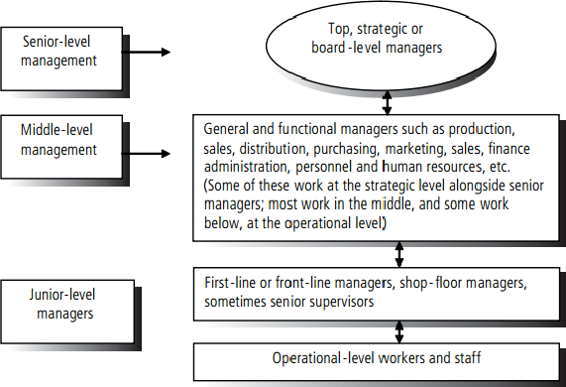organizations? In traditionally structured organizations managers can be classified as first- line, middle, or top.

Figure 1.1. Common terms used to describe managers in an organisational hierarchy

It’s obvious that managers do their work in organizations. But what is an organization? It’s a deliberate arrangement of people to accomplish some specific purpose. Your college or university is an organization; so are fraternities and sororities, government departments, churches, Facebook, your neighborhood grocery store, the United Way, the St. Louis Cardinals baseball team, and the Mayo Clinic. All are considered organizations and have three common characteristics. First, an organization has a distinct purpose. Second, each organization is composed of people. Third, all organizations develop some deliberate structure within which members do their work. That structure may be open and flexible, with no specific job duties or strict adherence to explicit job arrangements.

Management involves coordinating and overseeing the work activities of others so that their activities are completed efficiently and effectively. We already know that coordinating and overseeing the work of others is what distinguishes a managerial position from a nonmanagerial one. However, this doesn’t mean that managers can do what they want anytime, anywhere, or in any way. Instead, management involves ensuring that work activities are completed efficiently and effectively by the people responsible for doing them,

or at least that’s what managers aspire to do. Efficiency refers to getting the most output from the least amount of inputs. Management is also concerned with being effective, completing activities so that organizational goals are attained. Effectiveness is often described as “doing the right things”—that is, doing those work activities that will help the organization reach its goals.

Because organizations exist to achieve some particular purpose, someone must define that purpose and the means for its achievement. Managers are that someone. As managers engage in **planning**, they set goals, establish strategies for achieving those goals, and develop plans to integrate and coordinate activities. Managers are also responsible for arranging and structuring work to accomplish the organization’s goals. We call this function **organizing**. Every organization has people, and a manager’s job is to work with and through people to accomplish goals. This is the **leading** function. The final management function is **controlling**. After goals and plans are set (planning), tasks and structural arrangements put in place (organizing), and people hired, trained, and motivated (leading), there has to be some evaluation of whether things are going as planned.

In today’s world, managers are dealing with global economic and political uncertainties, changing workplaces, ethical issues, security threats, and changing technology.

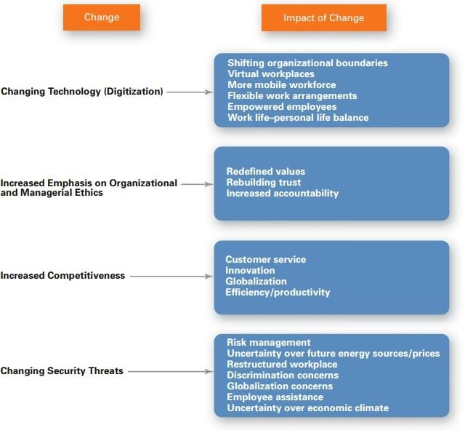

Figure 1.2. Changing and impact of change

You may be wondering why you need to study management. If you’re majoring in accounting or marketing or any field other than management, you may not understand how studying management is going to help you in your career. We can explain the value of studying management by looking at three things: the universality of management and the reality of work.

# Universality of management:

The reality that management is needed in all types and sizes of organizations, at all organizational levels, in all organizational areas, and in organizations no matter where located.

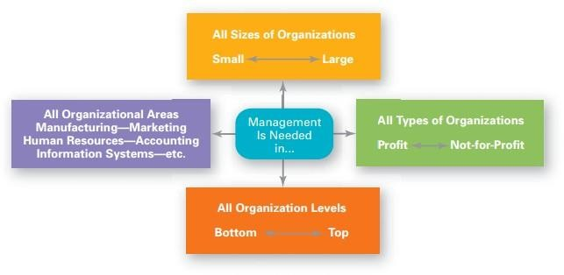

Figure 1.3. Management is needed in all types

# The Reality of Work

Another reason for studying management is the reality that for most of you, once you graduate from college and begin your career, you will either manage or be managed. For those who plan to be managers, an understanding of management forms the foundation upon which to build your management skills.

Omnipotent view of management: The view that managers are directly responsible for an organization’s success or failure.

Symbolic view of management: The view that much of an organization’s success or failure is due to external forces outside managers’ control.

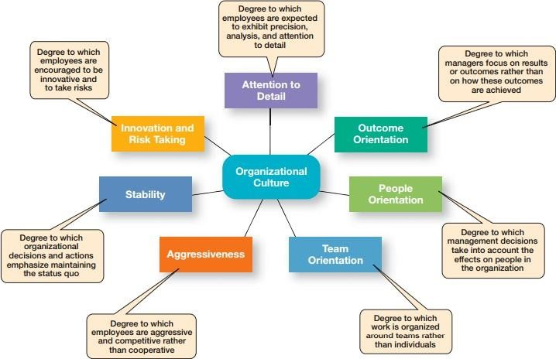Organizational culture has been described as the shared values, principles, traditions, and ways of doing things that influence the way organizational members act. In most organizations, these shared values and practices have evolved over time and determine, to a large extent, how “things are done around here.”

Figure 1.4: Organizational Culture

**CHAPTER 2. MANAGEMENT AND BUSINESS ORGANIZATION**

# Integrative Managerial Issues

One important feature of today’s global environment is global trade which, if you remember history class, isn’t new. Countries and organizations have been trading with each other for centuries. Global trade today is shaped by two forces: regional trading alliances and trade mechanisms that ensure that global trade can happen. When organizations do go international, they often use different approaches. Managers who want to get into a global market with minimal investment may start with global sourcing (also called global outsourcing), which is purchasing materials or labor from around the world wherever it is cheapest. The goal: take advantage of lower costs in order to be more competitive.

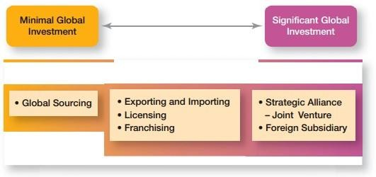

Figure 2.1. How Organizations Go Global

# Managing in a Global Environment

# The economic environment

A global manager must be aware of economic issues when doing business in other countries. First, it’s important to understand a country’s type of economic system. The two major types are a free market economy and a planned economy. A free market economy is one in which resources are primarily owned and controlled by the private sector. A planned economy is one in which economic decisions are planned by a central government. Actually, no economy is purely free market or planned. For instance, the United States and United Kingdom are toward the free market end of the spectrum but do have governmental intervention and

controls. The economies of Vietnam and North Korea are more planned. China is also a more planned economy, but until recently had been moving toward being more free market. Why would managers need to know about a country’s economic system? Because it, too, has the potential to constrain decisions. Other economic issues managers need to understand include currency exchange rates, inflation rates, and diverse tax policies.

# The political/legal environment

U.S. managers are accustomed to a stable legal and political system. Changes tend to be slow, and legal and political procedures are well established. Elections are held at regular intervals, and even when the political party in power changes after an election, it’s unlikely that anything too radical will happen. The stability of laws allows for accurate predictions. However, this certainly isn’t true for all countries.

# The cultural environment

Organizations have different cultures. Countries have cultures too. National culture includes the values and attitudes shared by individuals from a specific country that shape their behavior and their beliefs about what is important. Which is more important to a manager— national culture or organizational culture? Research indicates that national culture has a greater effect on employees than does their organization’s culture.

# Global Management in Today’s World

Doing business globally today isn’t easy! As we look at managing in today’s global environment, we want to focus on two important aspects. The first aspect involves the challenges associated with globalization, especially in relation to the openness that’s part of being global. The second aspect revolves around the challenges of managing a global workforce.

As globalization continues to be important for businesses, it’s obvious that managers need to understand how to best manage that global workforce. Some researchers have suggested that managers need cultural intelligence or cultural awareness and sensitivity skills. Cultural intelligence encompasses three main dimensions: (1) knowledge of culture as a concept—how cultures vary and how they affect behavior; (2) mindfulness— the ability to pay attention to

signals and reactions in different cross-cultural situations; and (3) behavioral skills—using one’s knowledge and mindfulness to choose appropriate behaviors in those situations.

# Managing Diversity

# Diversity

Diversity has been “one of the most popular business topics over the last two decades. It ranks with modern business disciplines such as quality, leadership, and ethics. Despite this popularity, it’s also one of the most controversial and least understood topics. What’s our definition of workplace diversity? We’re defining it as the ways in which people in an organization are different from and similar to one another. Notice that our definition not only focuses on the differences, but the similarities of employees.

# Types of Workplace Diversity

As we’ve seen so far, diversity is a big issue, and an important issue, in today’s workplaces. What types of dissimilarities—that is, diversity—do we find in those workplaces? Figure 2.1 shows several types of workplace diversity.

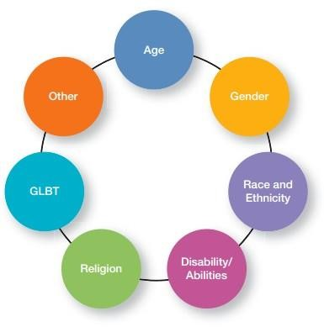

Figure 2.2. Types of Diversity Found in Workplaces

# Challenges in Managing Diversity

Despite the benefits that we know workforce diversity brings to organizations, managers still face challenges in creating accommodating and safe work environments for diverse employees. In this section, we’re going to look at two of those challenges: personal bias and the glass ceiling.

Bias is a term that describes a tendency or preference toward a particular perspective or ideology. It’s generally seen as a “one-sided” perspective. Our personal biases cause us to have preconceived opinions about people or things. One outcome of our personal biases can be prejudice, a preconceived belief, opinion, or judgment toward a person or a group of people. Our prejudice can be based on all the types of diversity we discussed: race, gender, ethnicity, age, disability, religion, sexual orientation, or even other personal characteristics. A major factor in prejudice is stereotyping, which is judging a person on the basis of one’s

perception of a group to which he or she belongs. For instance, “Married persons are more stable employees than single persons” is an example of stereotyping. Both prejudice and stereotyping can lead to someone treating others who are members of a particular group unequally. That’s what we call discrimination, which is when someone acts out their prejudicial attitudes toward people who are the targets of their prejudice. Discrimination, whether intentional or not, can lead to serious negative consequences for employers. But it’s not just the potential financial consequences organizations and managers face for discriminatory actions. It’s the reduced employee productivity, negative and disruptive interpersonal conflicts, increased employee turnover, and overall negative climate that can lead to serious problems for managers. Even if an organization has never had an employment discrimination lawsuit filed against it, managers need to aggressively work to eliminate unfair discrimination.

In the 1980s, the term glass ceiling, first used in a Wall Street Journal article, refers to the invisible barrier that separates women and minorities from top management positions. Research on the glass ceiling has looked at identifying the organizational practices and interpersonal biases that have blocked women’s advancement. Findings from those studies have ranged from lack of mentoring, sex stereotyping, views that associate masculine traits with leader effectiveness, and bosses’ perceptions of family–work conflict

# Workplace Diversity Initiatives

Workplace diversity management initiatives include top management commitment to diversity; mentoring, which is a process whereby an experienced organizational member provides advice and guidance to a less-experienced member; diversity skills training; and employee resource groups, which are groups made up of employees connected by some common dimension of diversity

# Managing Social Responsibility and Ethics

# Social Responsibility

Social obligation is when a firm engages in social actions because of its obligation to meet certain economic and legal responsibilities. The organization does what it’s obligated to do and nothing more. This idea reflects the classical view of social responsibility, which says that management’s only social responsibility is to maximize profits. We define social

responsibility as a business’s intention, beyond its legal and economic obligations, to do the right things and act in ways that are good for society. Our definition assumes that a business obeys the law and cares for its stockholders, but adds an ethical imperative to do those things that make society better and not to do those that make it worse. A socially responsible organization does what is right because it feels it has an ethical responsibility to do so.

# Managers and Ethical Behavior

As managers plan, organize, lead, and control, they must consider ethical dimensions. What do we mean by ethics? We’re defining it as the principles, values, and beliefs that define right and wrong decisions and behavior. Many decisions that managers make require them to consider both the process and who’s affected by the result. An organization’s managers do play an important role here. They’re responsible for creating an environment that encourages employees to embrace the culture and the desired values as they do their jobs. In fact, research shows that the behavior of managers is the single most important influence on an individual’s decision to act ethically or unethically. A strong culture exerts more influence on employees than a weak one. If a culture is strong and supports high ethical standards, it has a powerful and positive influence on the decision to act ethically or unethically.

# Social Responsibility and Ethics Issues In Today’s World

Managers can manage ethical lapses and social irresponsibility by being strong ethical leaders and by protecting employees who raise ethical issues. The example set by managers has a strong influence on whether employees behave ethically. Ethical leaders also are honest, share their values, stress important shared values, and use the reward system appropriately. Managers can protect whistle-blowers (employees who raise ethical issues or concerns) by encouraging them to come forward, by setting up toll-free ethics hotlines, and by establishing a culture in which employees can complain and be heard without fear of reprisal. Social entrepreneurs play an important role in solving social problems by seeking out opportunities to improve society by using practical, innovative, and sustainable approaches. Social entrepreneurs want to make the world a better place and have a driving passion to make that happen. Businesses can promote positive social change through corporate philanthropy and employee volunteering efforts.

# Managing Change and Innovation

# Types of Organizational Change

We classify these changes as organizational change, which is any alteration of people, structure, or technology. Organizational changes often need someone to act as a catalyst and assume the responsibility for managing the change process—that is, a change agent. Change agents can be a manager within the organization, but could be a nonmanager. Changing structure includes any change in structural variables such as reporting relationships, coordination mechanisms, employee empowerment, or job redesign. Changing technology encompasses modifications in the way work is performed or the methods and equipment that are used. Changing people refers to changes in attitudes, expectations, perceptions, and behavior of individuals or groups.

# Contemporary Issues in Managing Change

The shared values that comprise an organization’s culture are relatively stable, which makes it difficult to change. Managers can do so by being positive role models; creating new stories, symbols, and rituals; selecting, promoting, and supporting employees who adopt the new values; redesigning socialization processes; changing the reward system, clearly specifying expectations; shaking up current subcultures; and getting employees to participate in change. Stress is the adverse reaction people have to excessive pressure placed on them from extraordinary demands, constraints, or opportunities. To help employees deal with stress, managers can address job-related factors by making sure an employee’s abilities match the job requirements, improve organizational communications, use a performance planning program, or redesign jobs. Addressing personal stress factors is trickier, but managers could offer employee counseling, time management programs, and wellness programs. Making change happen successfully involves focusing on making the organization change capable, making sure managers understand their own role in the process, and giving individual employees a role in the process.

# Stimulating Innovation

Creativity is the ability to combine ideas in a unique way or to make unusual associations between ideas. Innovation is turning the outcomes of the creative process into useful products or work methods. Important structural variables include an organic-type structure, abundant

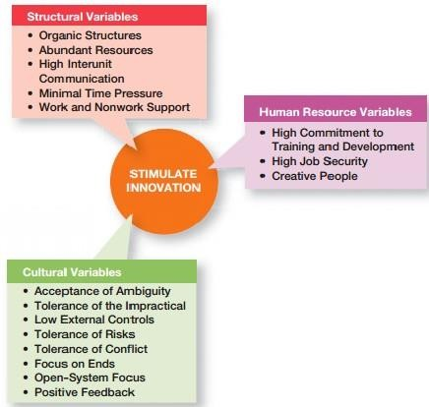resources, frequent communication between organizational units, minimal time pressure, and support. Important cultural variables include accepting ambiguity, tolerating the impractical, keeping external controls minimal, tolerating risk, tolerating conflict, focusing on ends not means, using an open-system focus, providing positive feedback, and being an empowering leader. Important human resource variables include high commitment to training and development, high job security, and encouraging individuals to be idea champions.

Figure 2.3. Innovations variables

# Planning

**Planning** (also called **forethought**) is the process of thinking about and organizing the activities required to achieve a desired goal. It involves the creation and maintenance of a plan, such as psychological aspects that require conceptual skills. There are even a couple of tests to measure someone’s capability of planning well. As such, planning is a fundamental property of intelligent behavior.

Also, planning has a specific process and is necessary for multiple occupations (particularly in fields such as management, business, etc.). In each field there are different types of plans that help companies achieve efficiency and effectiveness. An important, albeit often ignored aspect of planning, is the relationship it holds to forecasting. Forecasting can be described as

predicting what the future will look like, whereas planning predicts what the future should look like for multiple scenarios. Planning combines forecasting with preparation of scenarios and how to react to them. Planning is one of the most important project management and time management techniques. Planning is preparing a sequence of action steps to achieve some specific goal. If a person does it effectively, he can reduce much the necessary time and effort of achieving the goal. A plan is like a map. When following a plan, he can always see how much he has progressed towards his project goal and how far he is from his destination.

# Foundations of Planning

Planning involves defining the organization’s goals, establishing an overall strategy for achieving those goals, and developing plans for organizational work activities. The four purposes of planning include providing direction, reducing uncertainty, minimizing waste and redundancy, and establishing the goals or standards used in controlling. Studies of the planning-performance relationship have concluded that formal planning is associated with positive financial performance, for the most part; it’s more important to do a good job of planning and implementing the plans than doing more extensive planning; the external environment is usually the reason why companies that plan don’t achieve high levels of performance; and the planning-performance relationship seems to be influenced by the planning time frame.

# Goals and Plans

Goals are desired outcomes. Plans are documents that outline how goals are going to be met. Goals might be strategic or financial and they might be stated or real. Strategic plans apply to the entire organization while operational plans encompass a particular functional area. Long- term plans are those with a time frame beyond three years. Short-term plans cover one year or less. Specific plans are clearly defined and leave no room for interpretation. Directional plans are flexible and set out general guidelines. A single-use plan is a one-time plan designed to meet the needs of a unique situation. Standing plans are ongoing plans that provide guidance for activities performed repeatedly.

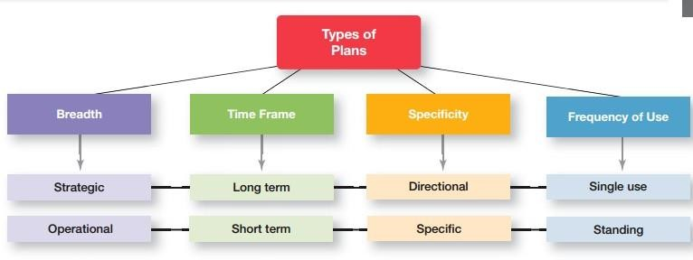

Figure 3.1: types of plans

# Setting Goals and Developing Plans

In traditional goal setting, goals are set at the top of the organization and then become subgoals for each organizational area. MBO (management by objectives) is a process of setting mutually agreed-upon goals and using those goals to evaluate employee performance. Well-written goals have six characteristics: (1) written in terms of outcomes, (2) measurable and quantifiable, (3) clear as to time frame, (4) challenging but attainable, (5) written down, and (6) communicated to all organizational members who need to know them. Goal setting involves these steps: review the organization’s mission; evaluate available resources; determine the goals individually or with input from others; write down the goals and communicate them to all who need to know them; and review results and change goals as needed. The contingency factors that affect planning include the manager’s level in the organization, the degree of environmental uncertainty, and the length of future commitments. The two main approaches to planning include the traditional approach, which has plans developed by top managers that flow down through other organizational levels and which may use a formal planning department. The other approach is to involve more organizational members in the planning process.

# Contemporary Issues in Planning

One contemporary planning issue is planning in dynamic environments, which usually means developing plans that are specific but flexible. Also, it’s important to continue planning even when the environment is highly uncertain. Finally, because there’s little time in a dynamic environment for goals and plans to flow down from the top, lower organizational levels

should be allowed to set goals and develop plans. Another contemporary planning issue involves using environmental scanning to help do a better analysis of the external environment. One form of environmental scanning, competitive intelligence, can be especially helpful in finding out what competitors are doing.

# Strategic Management

Strategic management is what managers do to develop the organization’s strategies. Strategies are the plans for how the organization will do whatever it’s in business to do, how it will compete successfully, and how it will attract and satisfy its customers in order to achieve its goals. A business model is how a company is going to make money. Strategic management is important for three reasons. First, it makes a difference in how well organizations perform. Second, it’s important for helping managers cope with continually changing situations. Finally, strategic management helps coordinate and focus employee efforts on what’s important.

# The strategic management process

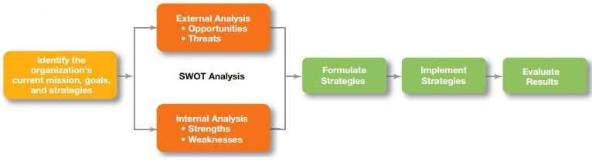(see figure 3.2) is a six-step process that encompasses strategy planning, implementation, and evaluation.

# Corporate Strategies

A growth strategy is when an organization expands the number of markets served or products offered, either through current or new businesses. The types of growth strategies include concentration, vertical integration (backward and forward), horizontal integration, and diversification (related and unrelated). A stability strategy is when an organization makes no significant changes in what it’s doing. Both renewal strategies— retrenchment and

turnaround—address organizational weaknesses that are leading to performance declines. The BCG matrix is a way to analyze a company’s portfolio of businesses by looking at a business’s market share and its industry’s anticipated growth rate. The four categories of the BCG matrix are cash cows, stars, question marks, and dogs.

# Competitive Strategies

An organization’s competitive advantage is what sets it apart, its distinctive edge. A company’s competitive advantage becomes the basis for choosing an appropriate competitive strategy. Porter’s five forces model assesses the five competitive forces that dictate the rules of competition in an industry: threat of new entrants, threat of substitutes, bargaining power of buyers, bargaining power of suppliers, and current rivalry. Porter’s three competitive strategies are as follows: cost leadership (competing on the basis of having the lowest costs in the industry), differentiation (competing on the basis of having unique products that are widely valued by customers), and focus (competing in a narrow segment with either a cost advantage or a differentiation advantage)

# Current Strategic Management Issues

Managers face three current strategic management issues: strategic leadership, strategic flexibility, and important types of strategies for today’s environment. Strategic leadership is the ability to anticipate, envision, maintain flexibility, think strategically, and work with others in the organization to initiate changes that will create a viable and valuable future for the organization and includes eight key dimensions. Strategic flexibility—that is, the ability to recognize major external environmental changes, to quickly commit resources, and to recognize when a strategic decision isn’t working— is important because managers often face highly uncertain environments. Managers can use e-business strategies to reduce costs, to differentiate their firm’s products and services, to target (focus on) specific customer groups, or to lower costs by standardizing certain office functions. Another important e-business strategy is the clicksand-bricks strategy, which combines online and traditional stand-alone locations. Strategies managers can use to become more customer oriented include giving customers what they want, communicating effectively with them, and having a culture that emphasizes customer service. Strategies managers can use to become more innovative include

deciding their organization’s innovation emphasis (basic scientific research, product development, or process development) and its innovation timing (first mover or follower).

# Organizing

Organizing is a systematic process of structuring, integrating, co-ordinating task goals, and activities to resources in order to attain objectives.

# Basic Organizational Design

# Designing Organizational Structure

The key elements in organizational design are work specialization, chain of command, span of control, departmentalization, centralization-decentralization, and formalization. Traditionally, work specialization was viewed as a way to divide work activities into separate job tasks. Today’s view is that it is an important organizing mechanism but it can lead to problems. The chain of command and its companion concepts—authority, responsibility, and unity of command—were viewed as important ways of maintaining control in organizations. The contemporary view is that they are less relevant in today’s organizations. The traditional view of span of control was that managers should directly supervise no more than five to six individuals. The contemporary view is that the span of control depends on the skills and abilities of the manager and the employees and on the characteristics of the situation. The various forms of departmentalization are as follows: Functional groups jobs by functions performed; product groups jobs by product lines; geographical groups jobs by geographical region; process groups jobs on product or customer flow; and customer groups jobs on specific and unique customer groups. Authority refers to the rights inherent in a managerial position to tell people what to do and to expect them to do it. The acceptance view of authority says that authority comes from the willingness of subordinates to accept it. Line authority entitles a manager to direct the work of an employee. Staff authority refers to functions that support, assist, advise, and generally reduce some of managers’ informational burdens. Responsibility is the obligation or expectation to perform assigned duties. Unity of command states that a person should report to only one manager. Centralization- decentralization is a structural decision about who makes decisions—upper-level managers or lower-level employees. Formalization concerns the organization’s use of standardization and strict rules to provide consistency and control.

# Traditional Organizational Design

A simple structure is one with low departmentalization, wide spans of control, authority centralized in a single person, and little formalization. A functional structure groups similar or related occupational specialties together. A divisional structure is made up of separate business units or divisions.

# Adaptive Organizational Design

In a team structure, the entire organization is made up of work teams. The matrix structure assigns specialists from different functional departments to work on one or more projects being led by project managers. A project structure is one in which employees continuously work on projects. A virtual organization consists of a small core of fulltime employees and outside specialists temporarily hired as needed to work on projects. A network organization is an organization that uses its own employees to do some work activities and networks of outside suppliers to provide other needed product components or work processes. A learning organization is one that has developed the capacity to continuously learn, adapt, and change. It has certain structural characteristics including an emphasis on sharing information and collaborating on work activities, minimal structural and physical barriers, and empowered work team.

Flexible work arrangements give organizations the flexibility to deploy employees when and where they’re needed. Structural options include telecommuting, compressed workweeks, flextime, and job sharing. Telecommuting is a work arrangement in which employees work at home and are linked to the workplace by computer. A compressed workweek is one in which employees work longer hours per day but fewer days per week. Flextime is a scheduling system in which employees are required to work a specific number of hours a week but are free to vary those hours within certain limits. Job sharing is when two or more people split a full-time job.

# Managing Human Resources

Human research management is important for three reasons. First, it can be a significant source of competitive advantage. Second, it’s an important part of organizational strategies. Finally, the way organizations treat their people has been found to significantly impact organizational performance. The external factors that most directly affect the human research

management process are the economy, labor unions, legal environment, and demographic trends.

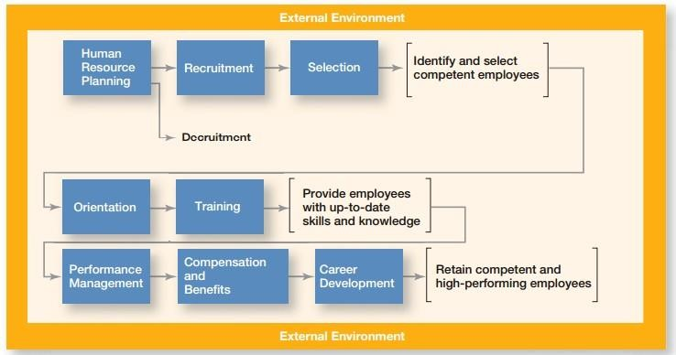

Figure 4.1. Human Resource Management

# Managing Teams

A group is two or more interacting and interdependent individuals who come together to achieve specific goals. Formal groups are work groups that are defined by the organization’s structure and have designated work assignments and specific tasks directed at accomplishing organizational goals. Informal groups are social groups. The forming stage consists of two phases: joining the group and defining the group’s purpose, structure, and leadership. The storming stage is one of intragroup conflict over who will control the group and what the group will be doing. The norming stage is when close relationships and cohesiveness develop as norms are determined. The performing stage is when group members began to work on the group’s task. The adjourning stage is when the group prepares to disband.

The major components that determine group performance and satisfaction include external conditions, group member resources, group structure, group processes, and group tasks. External conditions, such as availability of resources, organizational goals, and other factors, affect work groups. Group member resources (knowledge, skills, abilities, personality traits) can influence what members can do and how effectively they will perform in a group. Group roles generally involve getting the work done or keeping group members happy. Group norms are powerful influences on a person’s performance and dictate things such as work output

levels, absenteeism, and promptness. Pressures to conform can heavily influence a person’s judgment and attitudes. If carried to extremes, groupthink can be a problem. Status systems can be a significant motivator with individual behavioral consequences, especially if incongruence is a factor. What size group is most effective and efficient depends on the task the group is supposed to accomplish. Cohesiveness is related to a group’s productivity. Group decision making and conflict management are important group processes that play a role in performance and satisfaction. If accuracy, creativity, and degree of acceptance are important, a group decision may work best. Relationship conflicts are almost always dysfunctional. Low levels of process conflicts and low-to-moderate levels of task conflicts are functional. Effective communication and controlled conflict are most relevant to group performance when tasks are complex and interdependent.

The challenges of managing global teams can be seen in the group member resources, especially the diverse cultural characteristics; group structure, especially conformity, status, social loafing, and cohesiveness; group processes, especially with communication and managing conflict; and the manager’s role in making it all work. With the emphasis on teams in today’s organizations, managers need to recognize that people don’t automatically know how to be part of a team or to be an effective team member. Like any behavior, team members have to learn about the skill and then keep practicing and reinforcing it. In building team skills, managers must view their role as more of being a coach and developing others in order to create more committed, collaborative, and inclusive teams. Managers need to understand the patterns of informal connections among individuals within groups because those informal social relationships can help or hinder the group’s effectiveness.

# Leading

# Understanding Individual Behavior

Just like an iceberg, it’s the hidden organizational elements (attitudes, perceptions, norms, etc.) that make understanding individual behavior so challenging.

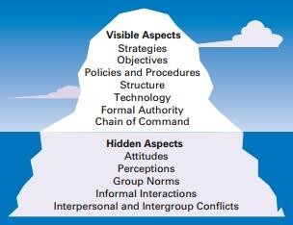

Figure 4.1. Organisation as Iceberg

Organization behavior (OB) focuses on three areas: individual behavior, group behavior, and organizational aspects. The goals of OB are to explain, predict, and influence behavior. Employee productivity is a performance measure of both efficiency and effectiveness. Absenteeism is the failure to report to work. Turnover is the voluntary and involuntary permanent withdrawal from an organization. Organizational citizenship behavior (OCB) is discretionary behavior that’s not part of an employee’s formal job requirements but it promotes the effective functioning of an organization. Job satisfaction is an individual’s general attitude toward his or her job. Workplace misbehavior is any intentional employee behavior that is potentially harmful to the organization or individuals within the organization.

# Attitudes and Job Performance

The cognitive component refers to the beliefs, opinions, knowledge, or information held by a person. The affective component is the emotional or feeling part of an attitude. The behavioral component refers to an intention to behave in a certain way toward someone or something. Job satisfaction refers to a person’s general attitude toward his or her job. Job involvement is the degree to which an employee identifies with his or her job, actively participates in it, and considers his or her job performance to be important to his or her self-worth. Organizational commitment is the degree to which an employee identifies with a particular organization and its goals and wishes to maintain membership in that organization. Employee engagement is when employees are connected to, satisfied with, and enthusiastic about their jobs. Job

satisfaction positively influences productivity, lowers absenteeism levels, lowers turnover rates, promotes positive customer satisfaction, moderately promotes OCB, and helps minimize workplace misbehavior. Individuals try to reconcile attitude and behavior inconsistencies by altering their attitudes, altering their behavior, or rationalizing the inconsistency.

# Personality

The MBTI measures four dimensions: social interaction, preference for gathering data, preference for decision making, and style of making decisions. The Big Five Model consists of five personality traits: extraversion, agreeableness, conscientiousness, emotional stability, and openness to experience. The five personality traits that help explain individual behavior in organizations are locus of control, Machiavellianism, self-esteem, self-monitoring, and risk- taking. Other personality traits include Type A/Type B personalities, proactive personality, and resilience. How a person responds emotionally and how they deal with their emotions is a function of personality. A person who is emotionally intelligent has the ability to notice and to manage emotional cues and information.

In recent years, research has shown that five basic personality dimensions underlie all others and encompass most of the significant variation in human personality.49 The five personality traits in the Big Five Model are: 1. Extraversion: The degree to which someone is sociable, talkative, assertive, and comfortable in relationships with others. 2. Agreeableness: The degree to which someone is good-natured, cooperative, and trusting. 3. Conscientiousness: The degree to which someone is reliable, responsible, dependable, persistent, and achievement oriented. 4. Emotional stability: The degree to which someone is calm, enthusiastic, and secure (positive) or tense, nervous, depressed, and insecure (negative). 5. Openness to experience: The degree to which someone has a wide range of interests and is imaginative, fascinated with novelty, artistically sensitive, and intellectual.

We can’t leave the topic of personality without looking at the important behavioral aspect of emotions. How we respond emotionally and how we deal with our emotions are typically functions of our personality. Emotions are intense feelings that are directed at someone or something. They’re object-specific; that is, emotions are reactions to an object. For instance, when a work colleague criticizes you for the way you spoke to a client, you might become angry at him. That is, you show emotion (anger) toward a specific object (your colleague). Because employees bring an emotional component with them to work every day, managers

need to understand the role that emotions play in employee behavior. How many emotions are there? Although you could probably name several dozen, research has identified six universal emotions: anger, fear, sadness, happiness, disgust, and surprise.Do these emotions surface in the workplace? Absolutely! I get angry after receiving a poor performance appraisal. I fear that I could be laid off as a result of a company cutback. I’m sad about one of my coworkers leaving to take a new job in another city. I’m happy after being selected as employee-of-the- month. I’m disgusted with the way my supervisor treats women on our team. And I’m surprised to find out that management plans a complete restructuring of the company’s retirement program.

# Perception

Perception is how we give meaning to our environment by organizing and interpreting sensory impressions. Because people behave according to their perceptions, managers need to understand it. The characteristics of the target being observed can also affect what’s perceived. Loud people are more likely than quiet people to be noticed in a group as are extremely attractive or unattractive individuals. The relationship of a target to its background also influences perception, as does our tendency to group close things and similar things together. You can experience these tendencies by looking at the visual perception examples shown in Figure 5.2. Notice how what you see changes as you look differently at each one.

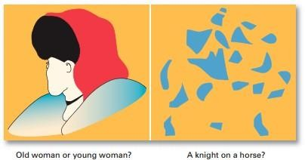

Figure 5.2. What Do You See?

Attribution theory depends on three factors. Distinctiveness is whether an individual displays different behaviors in different situations (that is, is the behavior unusual). Consensus is

whether others facing a similar situation respond in the same way. Consistency is when a person engages in behaviors regularly and consistently. Whether these three factors are high or low helps managers determine whether employee behavior is attributed to external or internal causes. The fundamental attribution error is the tendency to underestimate the influence of external factors and overestimate the influence of internal factors. The self- serving bias is the tendency to attribute our own successes to internal factors and to put the blame for personal failure on external factors. Three shortcuts used in judging others are assumed similarity, stereotyping, and the halo effect.

Managers need to recognize that their employees react to perceptions, not to reality. So whether a manager’s appraisal of an employee’s performance is actually objective and unbiased or whether the organization’s wage levels are among the highest in the community is less relevant than what employees perceive them to be. If individuals perceive appraisals to be biased or wage levels as low, they’ll behave as if those conditions actually exist. Employees organize and interpret what they see, so the potential for perceptual distortion is always present. The message is clear: Pay close attention to how employees perceive both their jobs and management actions.

# Learning

Operant conditioning argues that behavior is a function of its consequences. Managers can use it to explain, predict, and influence behavior. Social learning theory says that individuals learn by observing what happens to other people and by directly experiencing something. Managers can shape behavior by using positive reinforcement (reinforcing a desired behavior by giving something pleasant), negative reinforcement (reinforcing a desired response by withdrawing something unpleasant), punishment (eliminating undesirable behavior by applying penalties), or extinction (not reinforcing a behavior to eliminate it).

# Social Learning

Some 60 percent of the Radio City Rockettes have danced in prior seasons. The veterans help newcomers with “Rockette style”—where to place their hands, how to hold their hands, how to keep up stamina, and so forth.87 As the Rockettes are well aware, individuals can also learn by observing what happens to other people and just by being told about something as well as by direct experiences. Much of what we have learned comes from watching others

(models)—parents, teachers, peers, television and movie actors, managers, and so forth. This view that we can learn both through observation and direct experience is called social learning theory. The influence of others is central to the social learning viewpoint. The amount of influence that these models have on an individual is determined by four processes: learning Any relatively permanent change in behavior that occurs as a result of experience operant conditioning A theory of learning that says behavior is a function of its consequences social learning theory A theory of learning that says people can learn through observation and direct experience shaping behavior The process of guiding learning in graduated steps using reinforcement or lack of reinforcement 1. Attentional processes. People learn from a model when they recognize and pay attention to its critical features. We’re most influenced by models who are attractive, repeatedly available, thought to be important, or seen as similar to us. Retention processes. A model’s influence will depend on how well the individual remembers the model’s action, even after the model is no longer readily available. 3. Motor reproduction processes. After a person has seen a new behavior by observing the model, the watching must become doing. This process then demonstrates that the individual can actually do the modeled activities. 4. Reinforcement processes. Individuals will be motivated to exhibit the modeled behavior if positive incentives or rewards are provided. Behaviors that are reinforced will be given more attention, learned better, and performed more often. Shaping: A Managerial Tool Because learning takes place on the job as well as prior to it, managers are concerned with how they can teach employees to behave in ways that most benefit the organization. Thus, managers will often attempt to “mold” individuals by guiding their learning in graduated steps, through a method called shaping behavior. Consider the situation in which an employee’s behavior is significantly different from that sought by a manager. If the manager reinforced the individual only when he or she showed desirable responses, the opportunity for reinforcement might occur too infrequently. Shaping offers a logical approach toward achieving the desired behavior. We shape behavior by systematically reinforcing each successive step that moves the individual closer to the desired behavior. If an employee who has chronically been a half-hour late for work comes in only 20 minutes late, we can reinforce the improvement. Reinforcement would increase as an employee gets closer to the desired behavior. Four ways to shape behavior include positive reinforcement, negative reinforcement, punishment, and extinction. When a behavior is followed by something pleasant, such as praising an employee for a job well done, it’s called positive reinforcement

# Managers and Communication

Communication is the transfer and understanding of meaning. Interpersonal communication is communication between two or more people. Organizational communication includes all the patterns, networks, and systems of communication within an organization. The functions of communication include controlling employee behavior, motivating employees, providing a release for emotional expression of feelings and fulfillment of social needs, and providing information.

# Methods of Interpersonal Communication

Before communication can take place, a purpose, expressed as a message to be conveyed, must exist. It passes between a source (the sender) and a receiver. The message is converted to symbolic form (called encoding) and passed by way of some medium (channel) to the receiver, who retranslates the sender’s message (called decoding). The result is the transfer of meaning from one person to another

The communication process contains seven elements. First, a sender has a message. A message is a purpose to be conveyed. Encoding converts a message into symbols. A channel is the medium a message travels along. Decoding happens when the receiver retranslates a sender’s message. Finally, feedback occurs. Managers can evaluate the various communication methods according to their feedback, complexity capacity, breadth potential, confidentiality, encoding ease, decoding ease, time-space constraint, cost, interpersonal warmth, formality, scanability, and time of consumption. The communication methods include face-to-face, telephone, group meetings, formal presentations, memos, traditional mail, fax, employee publications, bulletin boards, other company publications, audio- and videotapes, hotlines, e-mail, computer conferencing, voice mail, teleconferences, and videoconferences.

Figure 5.3 illustrates the elements of the communication process. Note that the entire process is susceptible to noise—disturbances that interfere with the transmission, receipt, or feedback of a message. Typical examples of noise include illegible print, phone static, inattention by the receiver, or background sounds of machinery or coworkers. However, anything that interferes with understanding can be noise, and noise can create distortion at any point in the communication process.

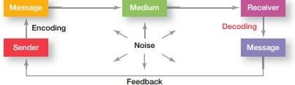

Figure 5.3. The Interpersonal Communication Process

# Effective Interpersonal Communication

The barriers to effective communication include filtering, emotions, information overload, defensiveness, language, and national culture. Managers can overcome these barriers by using feedback, simplifying language, listening actively, constraining emotions, and watching for nonverbal clues.

# Organizational Communication

Formal Versus Informal Communication Communication within an organization is described as formal or informal. Formal communication refers to communication that takes place within prescribed organizational work arrangements. For example, when a manager asks an employee to complete a task, that’s formal communication. Another example of formal communication occurs when an employee communicates a problem to his or her manager.

Informal communication is organizational communication not defined by the organization’s structural hierarchy. When employees talk with each other in the lunch room, as they pass in hallways, or as they’re working out at the company wellness facility, they engage in informal communication. Employees form friendships and communicate with each other. The informal communication system fulfills two purposes in organizations: (1) it permits employees to satisfy their need for social interaction, and (2) it can improve an organization’s performance by creating alternative, and frequently faster and more efficient, channels of communication. Formal communication is communication that takes place within prescribed organizational work arrangements. Informal communication is not defined by the organization’s structural hierarchy. Communication in an organization can flow downward, upward, laterally, and diagonally. The three communication networks include the chain, in which communication

flows according to the formal chain of command; the wheel, in which communication flows between a clearly identifiable and strong leader and others in a work team; and the all- channel, in which communication flows freely among all members of a work team. Managers should manage the grapevine as an important information network. The negative consequences of rumors can be minimized by communicating openly, fully, and honestly with employees. Workplace design also influences organizational communication. That design should support four types of employee work: focused work, collaboration, learning, and socialization. In each of these circumstances, communication must be considered.

# Organizational Communication Networks

The vertical and horizontal flows of organizational communication can be combined into a variety of patterns called communication networks. Exhibit 15-4 illustrates three common communication networks.

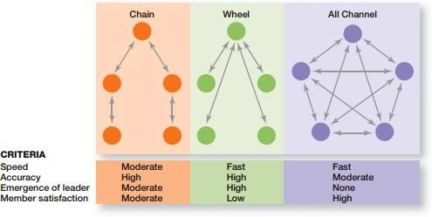

Figure 5.4. Organizational Communication Networks

Technology has radically changed the way organizational members communicate. It improves a manager’s ability to monitor performance; it gives employees more complete information to make faster decisions; it has provided employees more opportunities to collaborate and share information; and it has made it possible for people to be fully accessible, anytime anywhere. IT affects organizations by influencing the way that organizational members communicate, share information, and do their work.

# Motivating Employees

Motivation is the process by which a person’s efforts are energized, directed, and sustained toward attaining a goal. The energy element is a measure of intensity, drive, or vigor. The high level of effort needs to be directed in ways that help the organization achieve its goals. Employees must persist in putting forth effort to achieve those goals.

# Early Theories of Motivation

The best-known theory of motivation is probably Abraham Maslow’s hierarchy of needs theory. Maslow was a psychologist who proposed that within every person is a hierarchy of five needs: 1. Physiological needs: A person’s needs for food, drink, shelter, sex, and other physical requirements. 2. Safety needs: A person’s needs for security and protection from physical and emotional harm, as well as assurance that physical needs will continue to be met.

3. Social needs: A person’s needs for affection, belongingness, acceptance, and friendship. 4. Esteem needs: A person’s needs for internal esteem factors such as self-respect, autonomy, and achievement and external esteem factors such as status, recognition, and attention. 5. Self- actualization needs: A person’s needs for growth, achieving one’s potential, and self- fulfillment; the drive to become what one is capable of becoming.

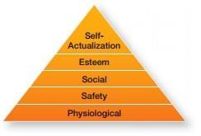

Figure 5.4. Maslow’s Hierarchy of Needs

A need that’s substantially satisfied no longer motivates. A Theory X manager believes that people don’t like to work or won’t seek out responsibility so they have to be threatened and

coerced to work. A Theory Y manager assumes that people like to work and seek out responsibility, so they will exercise self-motivation and self-direction.

Herzberg’s theory proposed that intrinsic factors associated with job satisfaction were what motivated people. Extrinsic factors associated with job dissatisfaction simply kept people from being dissatisfied.

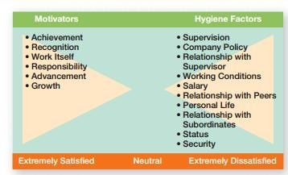

Figure 5.5: Herzberg’s Two Factor Theory

David McClelland and his associates proposed the three-needs theory, which says there are three acquired (not innate) needs that are major motives in work. These three needs include the need for achievement (nAch), which is the drive to succeed and excel in relation to a set of standards; the need for power (nPow), which is the need to make others behave in a way that they would not have behaved otherwise; and the need for affiliation (nAff), which is the desire for friendly and close interpersonal relationships. Of these three needs, the need for achievement has been researched the most.

# Contemporary Theories of Motivation

Goal-setting theory says that specific goals increase performance, and difficult goals, when accepted, result in higher performance than do easy goals.

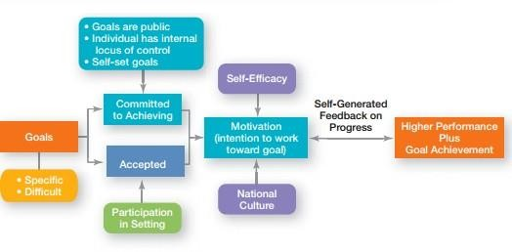

Figure 5.6. Goal Setting Theory

Important points in goal setting theory include intention to work toward a goal as a major source of job motivation; specific hard goals that produce higher levels of output than generalized goals; participation in setting goals as preferable to assigning goals, but not always; feedback that guides and motivates behavior, especially self-generated feedback; and contingencies that affect goal setting—goal commitment, self-efficacy, and national culture. Reinforcement theory says that behavior is a function of its consequences. To motivate, use positive rein forcers to reinforce desirable behaviors. Ignore undesirable behavior rather than punishing it. Job enlargement involves horizontally expanding job scope by adding more tasks or increasing how many times the tasks are done. Job enrichment vertically expands job depth by giving employees more control over their work. The job characteristics model says five core job dimensions (skill variety, task identity, task significance, autonomy, and feedback) are used to design motivating jobs.

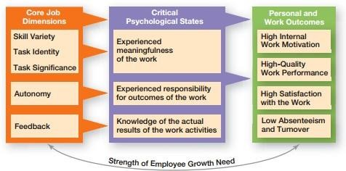

Figure 5.7. Job Characteristics Model

Another job design approach proposed looking at relational aspects and proactive aspects of jobs. Equity theory focuses on how employees compare their inputs–outcomes ratios to relevant others’ ratios. A perception of inequity will cause an employee to do something about it. Procedural justice has a greater influence on employee satisfaction than does distributive justice. Expectancy theory says that an individual tends to act in a certain way based on the expectation that the act will be followed by a desired outcome. Expectancy is the effort– performance linkage (how much effort do I need to exert to achieve a certain level of performance); instrumentality is the performance–reward linkage (achieving at a certain level of performance will get me a specific reward); and valence is the attractiveness of the reward (Is it the reward that I want?).

# Managers as Leaders

A leader is someone who can influence others and who has managerial authority. Leadership is a process of leading a group and influencing that group to achieve its goals. Managers should be leaders because leading is one of the four management functions.

# Early theories of leadership

Early attempts to define leader traits were unsuccessful although later attempts found seven traits associated with leadership. The University of Iowa studies explored three leadership styles. The only conclusion was that group members were more satisfied under a democratic leader than under an autocratic one. The Ohio State studies identified two dimensions of

leader behavior— initiating structure and consideration. A leader high in both those dimensions at times achieved high group task performance and high group member satisfaction, but not always. The University of Michigan studies looked at employee-oriented leaders and production-oriented leaders. They concluded that leaders who were employee oriented could get high group productivity and high group member satisfaction. The Managerial Grid looked at leaders’ concern for production and concern for people and identified five leader styles. Although it suggested that a leader who was high in concern for production and high in concern for people was the best, there was no substantive evidence for that conclusion. As the behavioral studies showed, a leader’s behavior has a dual nature: a focus on the task and a focus on the people.

# The three major contingency theories of leadership

Fiedler’s model attempted to define the best style to use in particular situations. He measured leader style—relationship oriented or task oriented—using the least-preferred coworker questionnaire. Fiedler also assumed a leader’s style was fixed. He measured three contingency dimensions: leader–member relations, task structure, and position power. The model suggests that task-oriented leaders performed best in very favorable and very unfavorable situations, and relationship-oriented leaders performed best in moderately favorable situations.

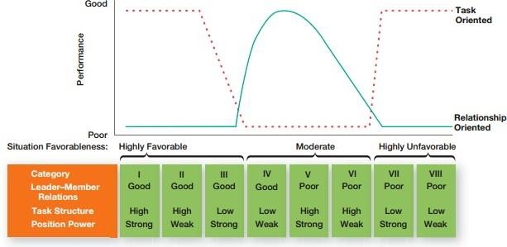

Figure 5.7. The Fiedler Model

Hersey and Blanchard’s situational leadership theory focused on followers’ readiness. They identified four leadership styles: telling (high task–low relationship), selling (high task–high relationship), participating (low task–high relationship), and delegating (low task–low relationship). They also identified four stages of readiness: unable and unwilling (use telling

style), unable but willing (use selling style), able but unwilling (use participative style), and able and willing (use delegating style). The path-goal model developed by Robert House identified four leadership behaviors: directive, supportive, participative, and achievement- oriented. He assumed that a leader can and should be able to use any of these styles. The two situational contingency variables were found in the environment and in the follower. Essentially the path-goal model says that a leader should provide direction and support as needed; that is, structure the path so the followers can achieve goals.

# Controlling

Controlling is the process of monitoring, comparing, and correcting work performance. As the final step in the management process, controlling provides the link back to planning. If managers didn’t control, they’d have no way of knowing whether goals were being met.

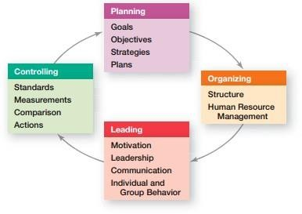

Figure 6.1. Planning-Controlling Link

Control is important because (1) it’s the only way to know if goals are being met, and if not, why; (2) it provides information and feedback so managers feel comfortable empowering employees; and (3) it helps protect an organization and its assets.

# The Control Process

The three steps in the control process are measuring, comparing, and taking action.

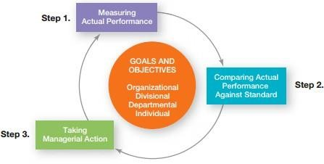

Figure 6.2. The Control Process

Measuring involves deciding how to measure actual performance and what to measure. Comparing involves looking at the variation between actual performance and the standard (goal). Deviations outside an acceptable range of variation need attention. Taking action can involve doing nothing, correcting the actual performance, or revising the standards. Doing nothing is self-explanatory. Correcting the actual performance can involve different corrective actions, which can either be immediate or basic. Standards can be revised by either raising or lowering them.

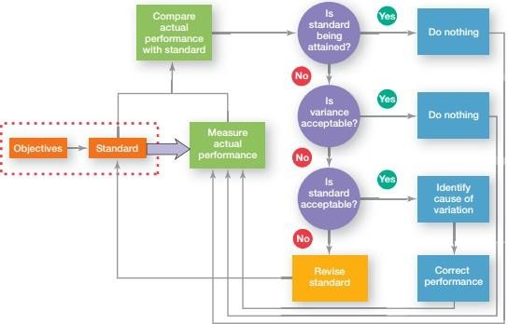

Figure 6.3. Managerial Decisions in the Control Process

Figure 6.3 summarizes the decisions a manager makes in controlling. The standards are goals that were developed during the planning process. These goals provide the basis for the control process, which involves measuring actual performance and comparing it against the standard. Depending on the results, a manager’s decision is to do nothing, correct the performance, or revise the standard.

# Controlling for Organizational Performance

Organizational performance is the accumulated results of all the organization’s work activities. Three frequently used organizational performance measures include (1) productivity, which is the output of goods or services produced divided by the inputs needed to generate that output; (2) effectiveness, which is a measure of how appropriate organizational goals are and how well those goals are being met; and (3) industry and company rankings compiled by various business publications.

# Tools for measuring Organizational Performance

Feedforward controls take place before a work activity is done.

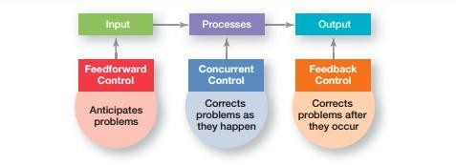

Figure 6.3: Types of Control

Concurrent controls take place while a work activity is being done. Feedback controls take place after a work activity is done. Financial controls that managers can use include financial ratios (liquidity, leverage, activity, and profitability) and budgets. One information control managers can use is an MIS, which provides managers with needed information on a regular basis. Others include comprehensive and secure controls such as data encryption, system firewalls, data backups, and so forth that protect the organization’s information. Balanced scorecards provide a way to evaluate an organization’s performance in four different areas rather than just from the financial perspective. Benchmarking provides control by finding the best practices among competitors or noncompetitors and from inside the organization itself.

# Managing Operations

# The Role of Operations Management

Operations management is the transformation process that converts resources into finished goods and services. Manufacturing organizations produced physical goods.

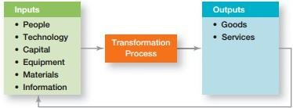

Figure 6.4. The Operations System

Figure 6.4 portrays this process in a simplified fashion. The system takes in inputs—people, technology, capital, equipment, materials, and information—and transforms them through various processes, procedures, work activities, and so forth into finished goods and services. Because every unit in an organization produces something, managers need to be familiar with operations management concepts in order to achieve goals efficiently and effectively.

Service organizations produce nonphysical outputs in the form of services. Productivity is a composite of people and operations variables. A manager should look for ways to successfully integrate people into the overall operations systems. Organizations must recognize the crucial role that operations management plays as part of their overall strategy in achieving successful performance.

Every organization produces something. Unfortunately, this fact is often overlooked except in obvious cases such as in the manufacturing of cars, cell phones, or lawnmowers. After all, manufacturing organizations produce physical goods. It’s easy to see the operations management (transformation) process at work in these types of organizations because raw materials are turned into recognizable physical products. But the transformation process isn’t as readily evident in service organizations that produce nonphysical outputs in the form of services. For instance, hospitals provide medical and health care services that help people manage their personal health, airlines provide transportation services that move people from one location to another, a cruise line provides a vacation and entertainment service, military forces provide defense capabilities, and the list goes on and on.

# Planning Techniques

# Techniques for Assessing the Environment

Three techniques help managers assess the organization’s environment: environmental scanning, forecasting, and benchmarking.

# Environmental Scanning

How can managers become aware of significant environmental changes such as a new law in Germany permitting shopping for “tourist items” on Sunday; the increased trend of counterfeit consumer products in South Africa; the precipitous decline in the working-age populations in Japan, Germany, Italy, and Russia; or the decrease in family size in Mexico? Managers in both small and large organizations use environmental scanning, which is the

screening of large amounts of information to anticipate and interpret changes in the environment. Extensive environmental scanning is likely to reveal issues and concerns that could affect an organization’s current or planned activities. Research has shown that companies that use environmental scanning have higher performance. Organizations that don’t keep on top of environmental changes are likely to experience the opposite! A fast- growing area of environmental scanning is **competitor intelligence**. It’s a process by which organizations gather information about their competitors and get answers to questions such as Who are they? What are they doing? How will what they’re doing affect us? Competitor intelligence experts suggest that 80 percent of what managers need to know about competitors can be found out from their own employees, suppliers, and customers. Competitor intelligence doesn’t have to involve spying. Advertisements, promotional materials, press releases, reports filed with government agencies, annual reports, want ads, newspaper reports, and industry studies are examples of readily accessible sources of information.

One type of environmental scanning that’s particularly important is **global scanning**. Because world markets are complex and dynamic, managers have expanded the scope of their scanning efforts to gain vital information on global forces that might affect their organizations. The value of global scanning to managers, of course, largely depends on the extent of the organization’s global activities. For a company that has significant global interests, global scanning can be quite valuable.

# Forecasting

The second technique managers can use to assess the environment is forecasting. Forecasting is an important part of planning and managers need forecasts that will allow them to predict future events effectively and in a timely manner. Environmental scanning establishes the basis for forecasts, which are predictions of outcomes. Virtually any component in an organization’s environment can be forecasted. Let’s look at how managers forecast and the effectiveness of those forecasts.

Forecasting techniques fall into two categories: quantitative and qualitative. **Quantitative forecasting** applies a set of mathematical rules to a series of past data to predict outcomes. These techniques are preferred when managers have sufficient hard data that can be used. **Qualitative forecasting**, in contrast, uses the judgment and opinions of knowledgeable individuals to predict outcomes. Qualitative techniques typically are used when precise data are limited or hard to obtain. Figure 7-1 describes some popular forecasting techniques.

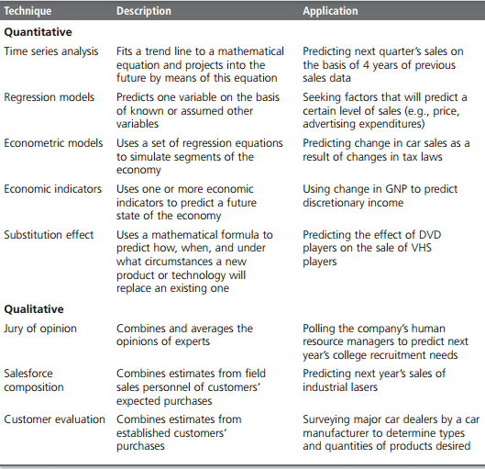

Figure 7-1: Forecasting Techniques

# Benchmarking

The basic idea behind benchmarking is that managers can improve performance by analyzing and then copying the methods of the leaders in various fields. Organizations such as Nissan, Payless Shoe Source, and the U.S. military, General Mills, United Airlines, and Volvo Construction Equipment have used benchmarking as a tool in improving performance. In fact, some companies have chosen some pretty unusual benchmarking partners! What does benchmarking involve? Figure 7-2 illustrates the four steps typically used in benchmarking.

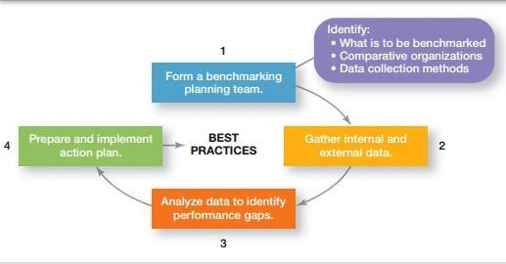

Figure 7-2: Steps in Benchmarking

# Techniques for Allocating Resources

Although managers can choose from a number of techniques for allocating resources (many of which are covered in courses on accounting, finance, and operations management), we’ll discuss two techniques here: budgeting and scheduling.

# Budgeting

A budget is a numerical plan for allocating resources to specific activities. Managers typically prepare budgets for revenues, expenses, and large capital expenditures such as equipment. It’s not unusual, though, for budgets to be used for improving time, space, and use of material resources. These types of budgets substitute nondollar numbers for dollar amounts. Such items as person-hours, capacity utilization, or units of production can be budgeted for daily, weekly, or monthly activities.

How to Improve Budgeting

* Collaborate and communicate.
* Be flexible.
* Goals should drive budgets—budgets should not determine goals.
* Coordinate budgeting throughout the organization.
* Use budgeting/planning software when appropriate.
* Remember that budgets are tools.
* Remember that profits result from smart management, not because you budgeted for them.

# Scheduling

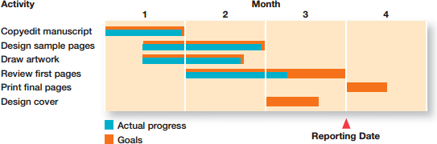Jackie is a manager at a Chico’s store in San Francisco. Every week, she determines employees ‘work hours and the store area where each employee will be working. If you observed any group of supervisors or department managers for a few days, you would see them doing much the same—allocating resources by detailing what activities have to be done, the order in which they are to be completed, who is to do each, and when they are to be completed. These managers are scheduling. Some useful scheduling devices including Gantt charts, load charts, and PERT network analysis. You can see at Figure 7-3 an example of Gantt chart.

Figure 7-3: A Gantt Chart