**People's Democratic Republic of Algeria**

**Ministry of Higher Education and Scientific Research**

**Faculty of Economic, Commercial and Management Sciences**

**University of tissemsilt**

**Master 01: Management /Human Resources Management**

**Semester: 02**

**Miss.Adane**

**Lecture:**

**Organizational Behaviour**

We are going to know the fundamental concepts of organizational behavior and its impact on the global scenario. We are also going to study the individual factors such as personality, attitude, learning, perception, motivation and ability with respect to organizational behavior and commitment.

**DEFINITION OF ORGANISATIONAL BEHAVIOUR**

Organisational behaviour can then defined as: “The study of human behaviour in organisational settings, the interface between human behaviour and the organisational context, and the organisation itself.”

**ELEMENTS OF ORGANISATIONAL BEHAVIOUR**

The key elements in the organisational behaviour are people, structure, technology and the environment in which the organisation operates.

**People:**

People make up the internal and social system of the organisation. They consists of individuals and groups. The groups may be big or small; formal or informal; official or unofficial. Groups are dynamic. They work in the organisation to achieve their objectives.

**Structure:**

Structure defines the formal relationships of the people in organisations. Different people in the organisation are performing different type of jobs and they need to be related in some structural way so that their work can be effectively co-ordinated.

**Technology:**

Technology such as machines and work processes provide the resources with which people work and affects the tasks that they perform. The technology used has a significant influence on working relationships. It allows people to do more and better work but it also restricts people in various ways.

**Environment:**

All organisations operate within an external environment. It is part of a larger system that contains many other elements such as government, the family and other organisations. All of these mutually influence each other in a complex system that creates a context for a group of people.

**Approaches to Organisational Behaviour :**

There are mainly four approaches to organisational behaviour. They are:

• A human resources approach

• A contingency approach

• A productivity approach

• A systems approach

**MODELS**

**An Organisational Behaviour System:**

Organisations achieve their goals by creating, communicating and operating an

organisational behaviour system as shown below:

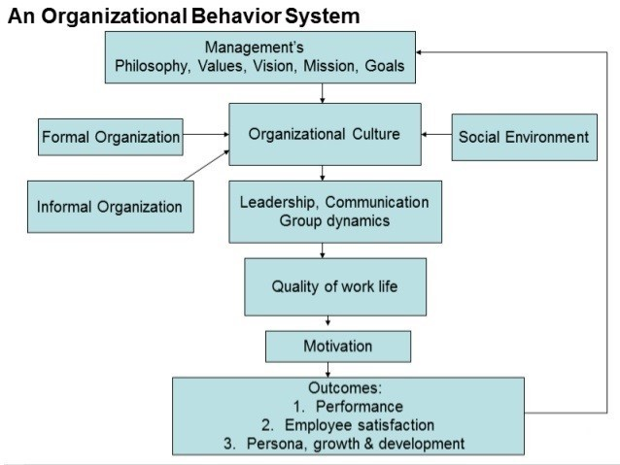

**Fig. 1: Model of Organizational Behavior system.**J W Newtrom and Keith Davis:

References

. Dr. Saravanakumar, (2019). UNIT 1 ORGANISATIONAL BEHAVIOUR.